Azure assignments –  
Lab 1

Lab-2:

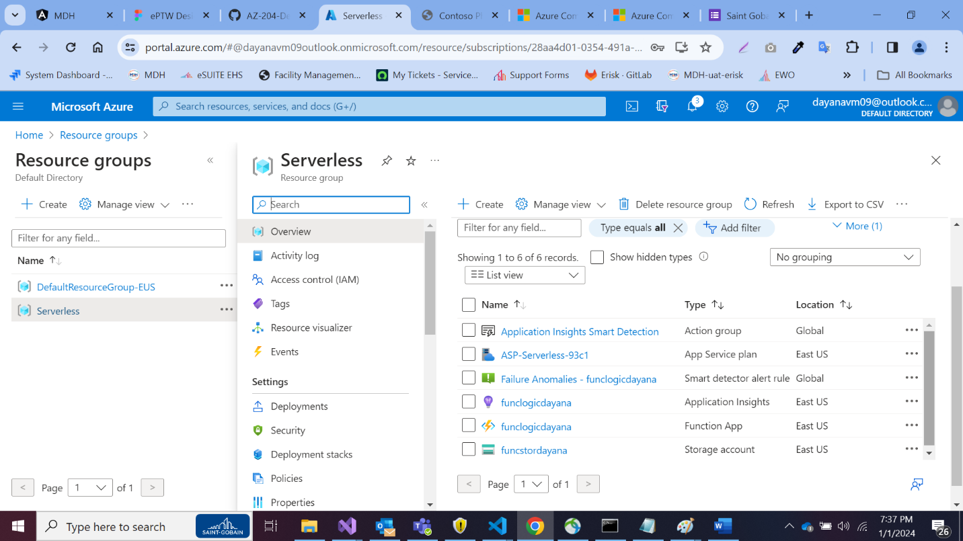

Lab 3:

REDDISH CONSOLE APP

AUTHENTICATOR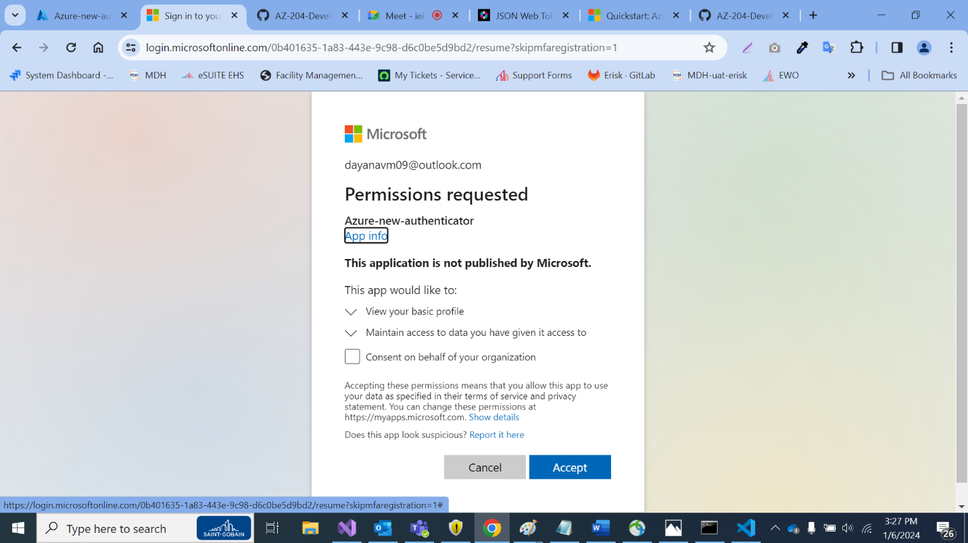

Key Vault

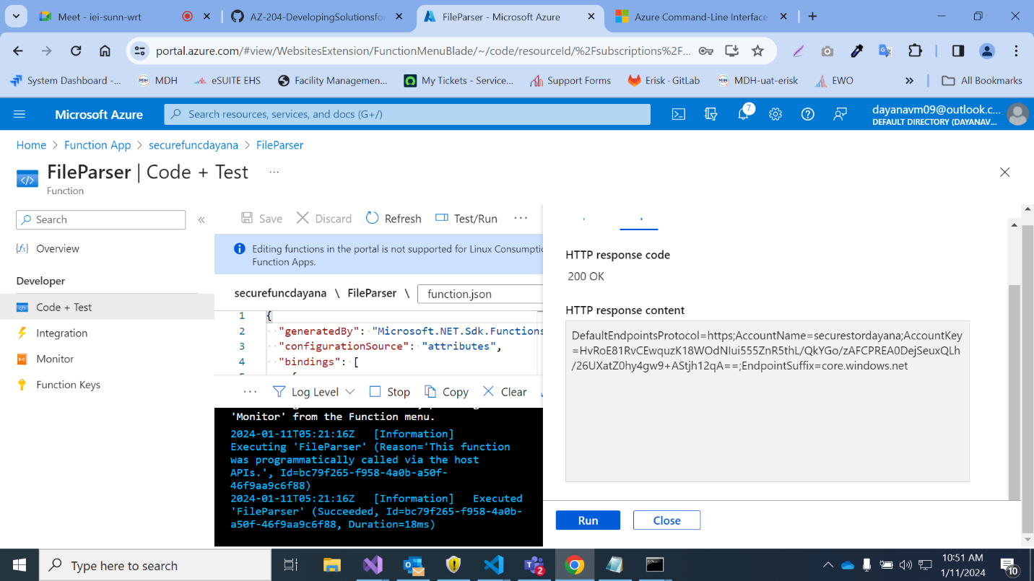

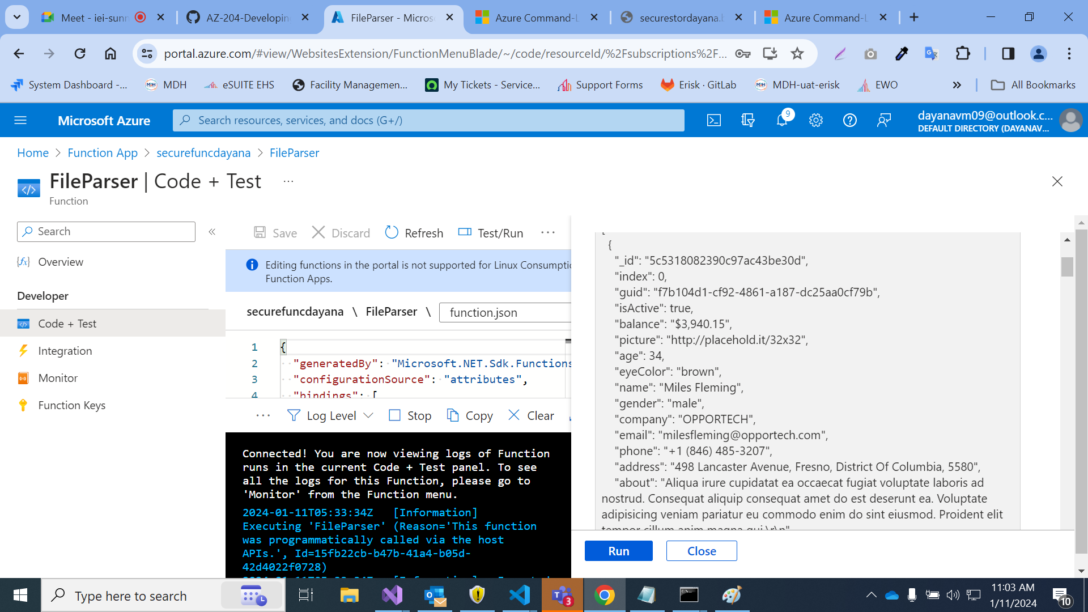

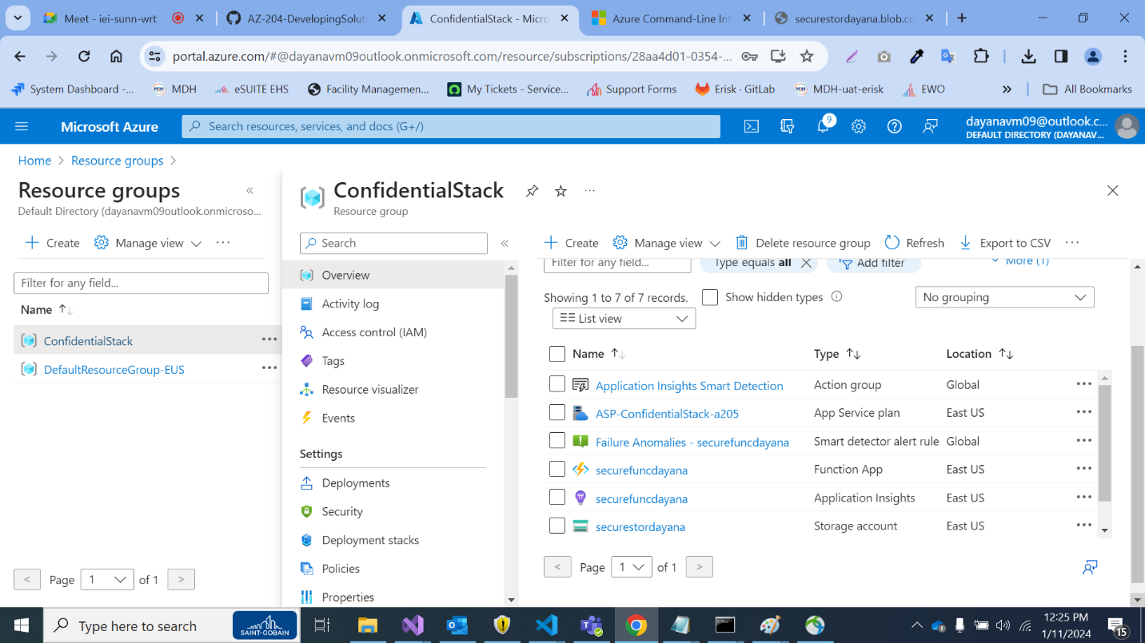

SERVICE BUS

CDN   
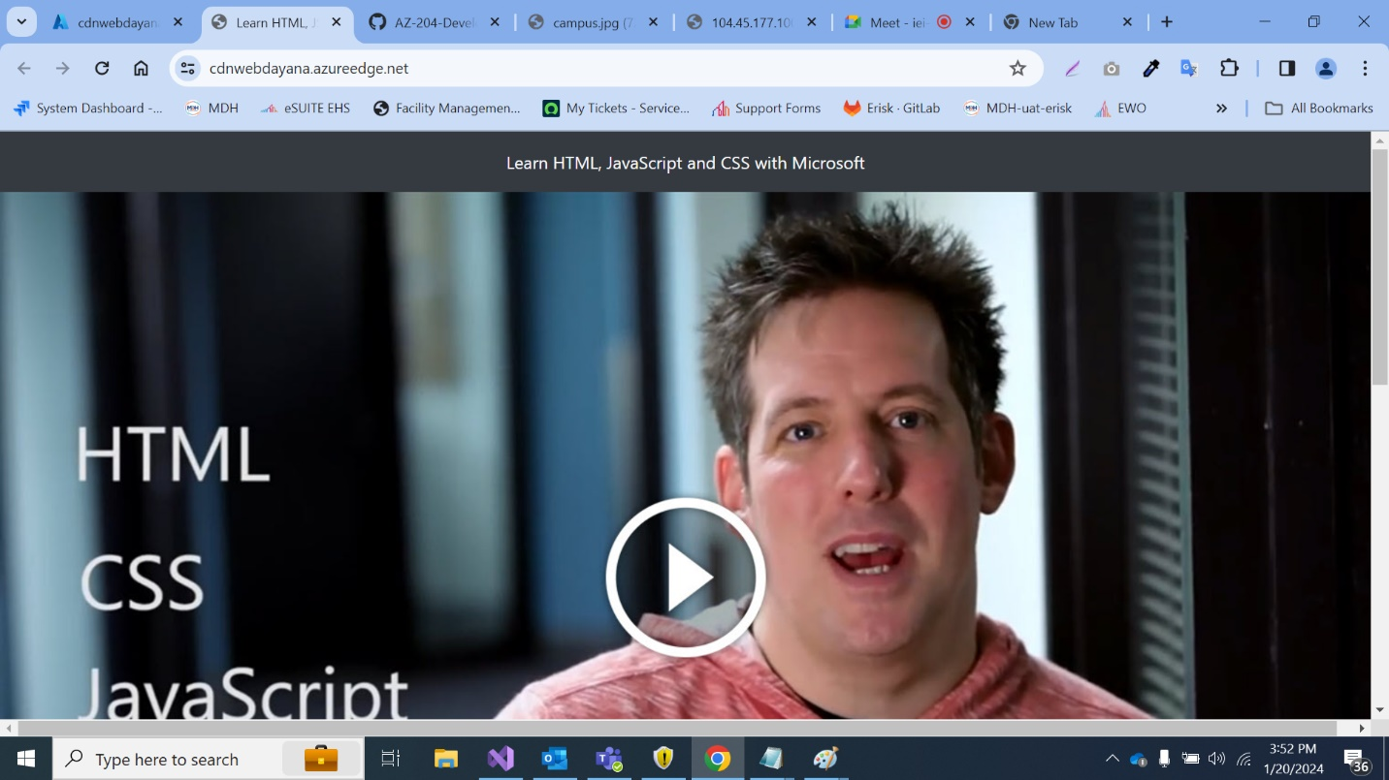

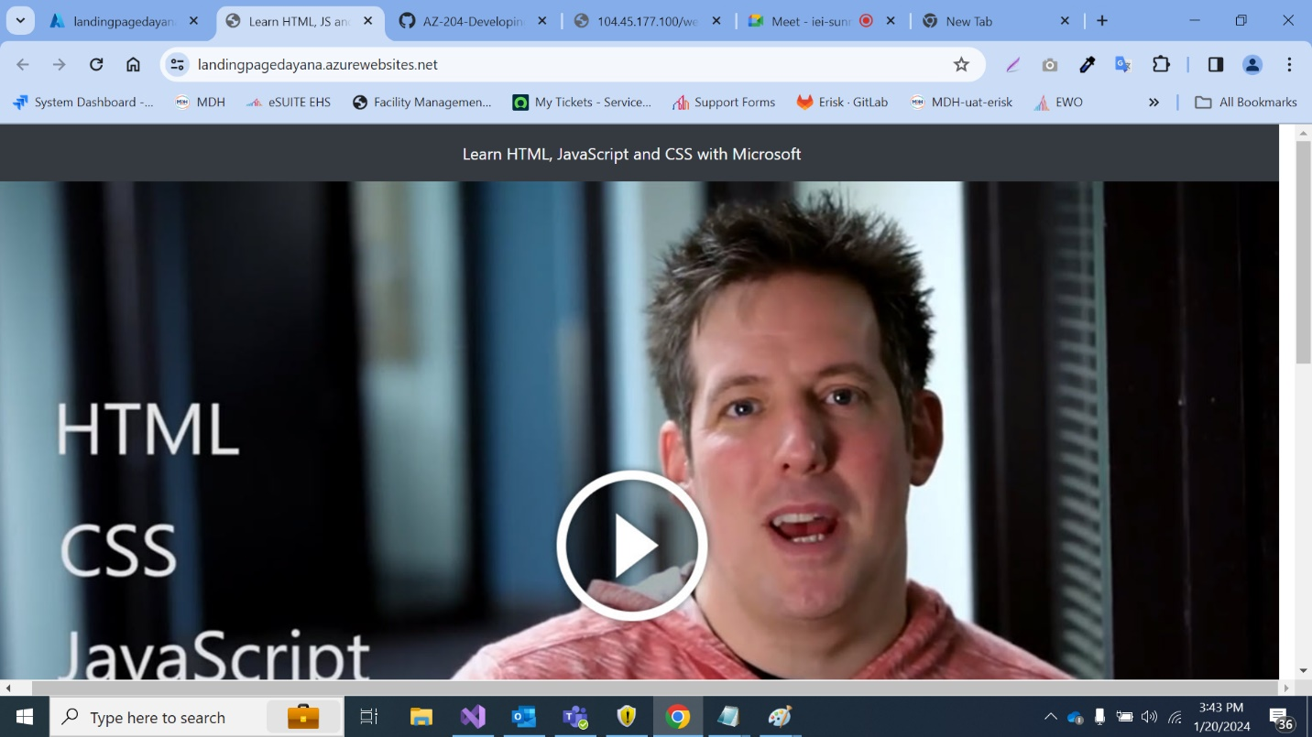

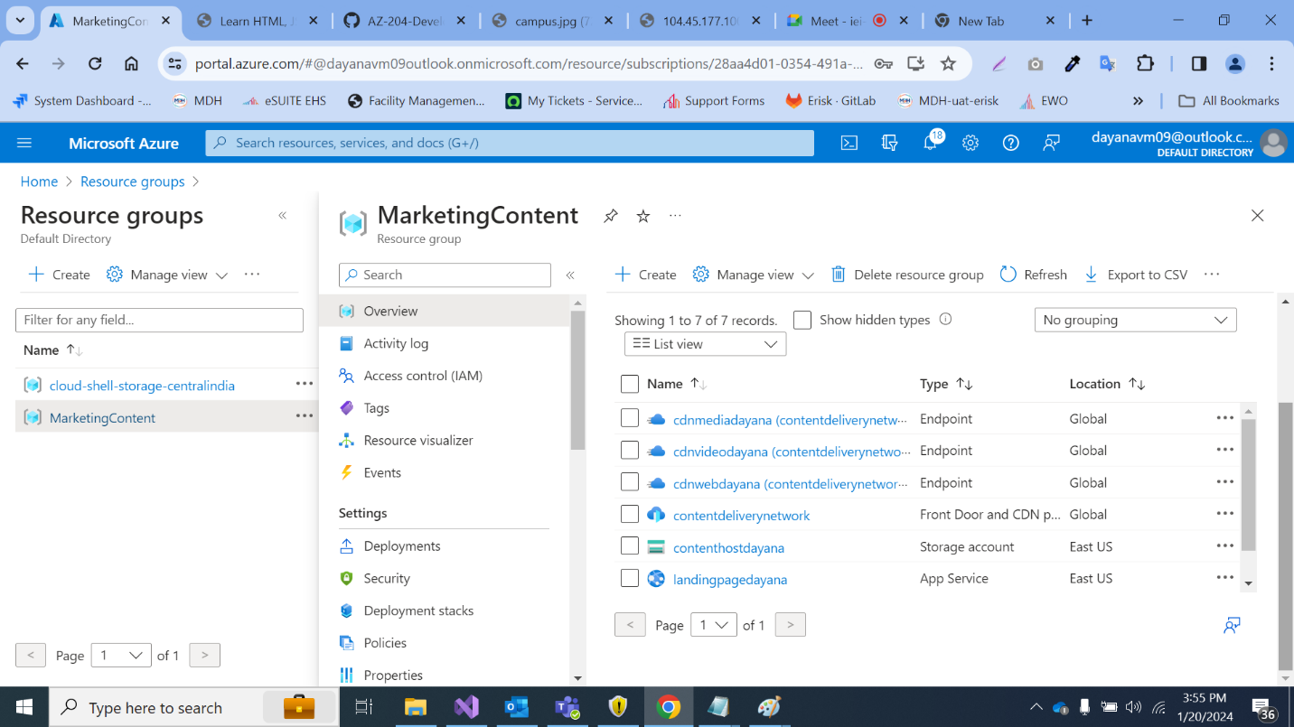

API Management  
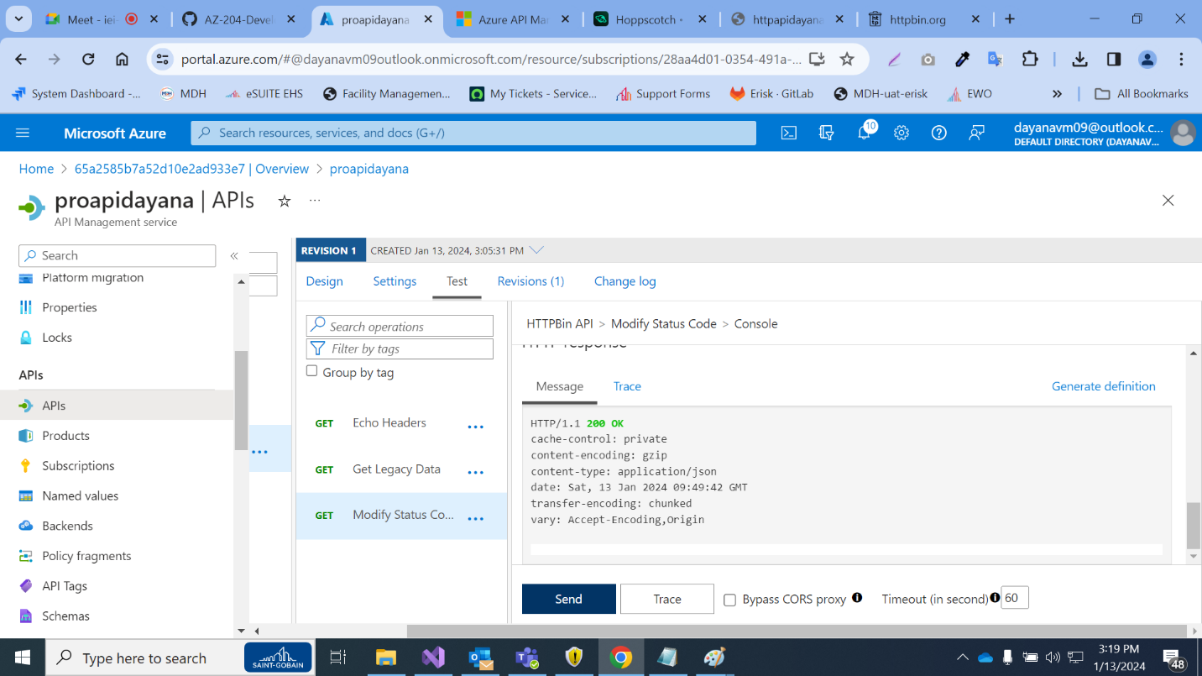

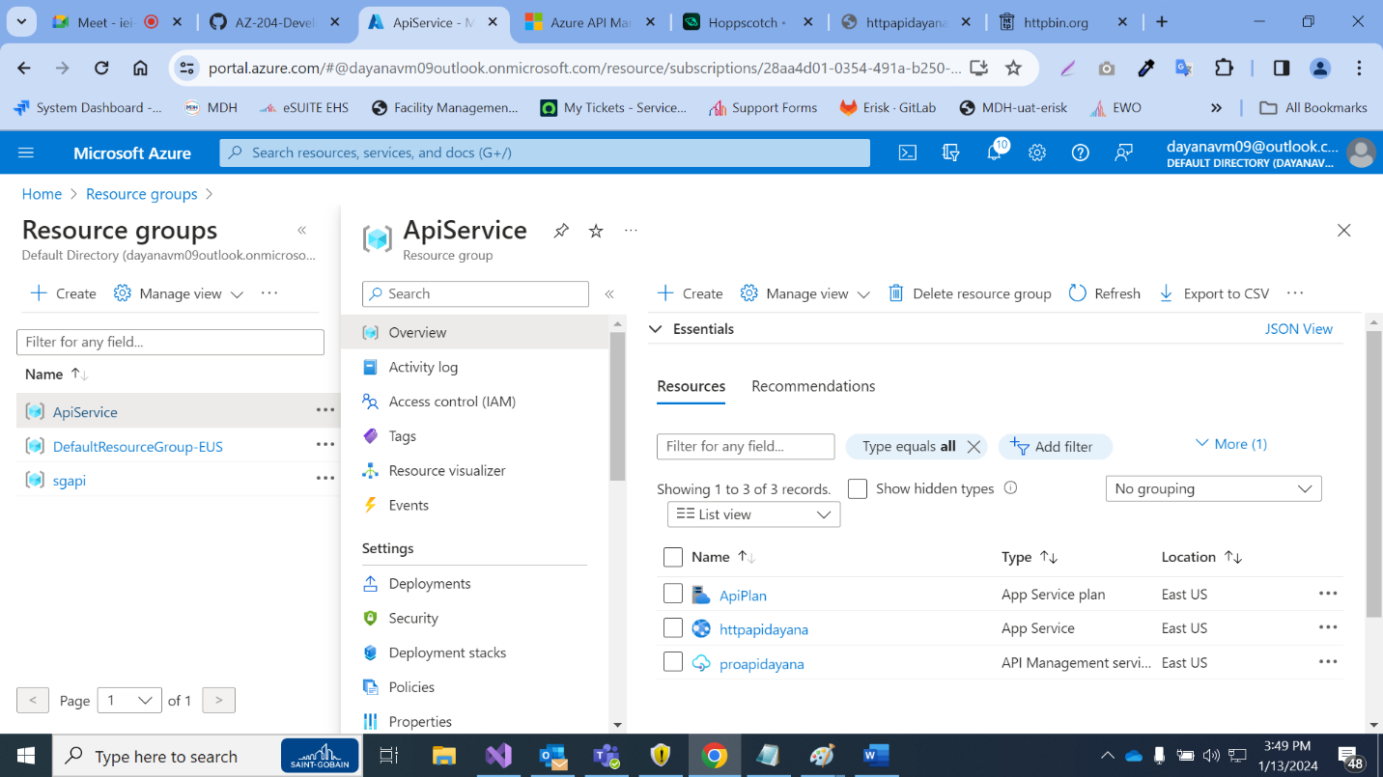

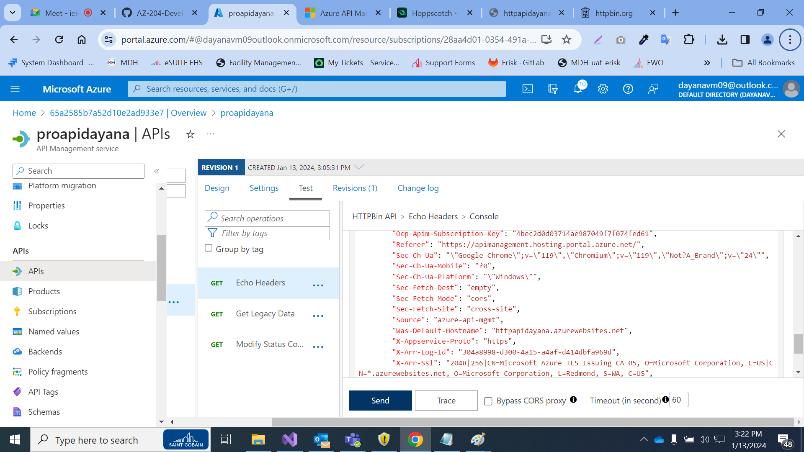

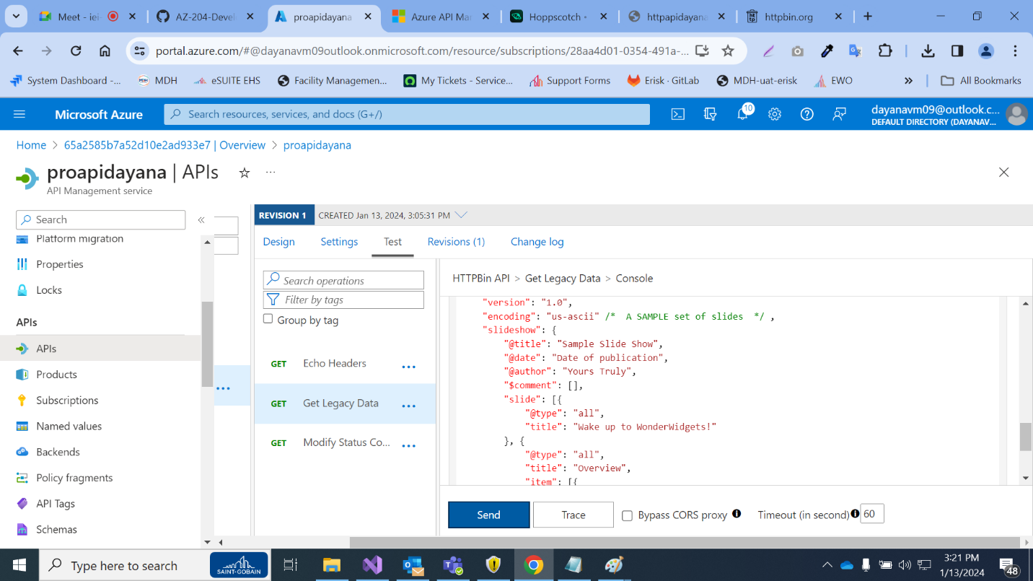

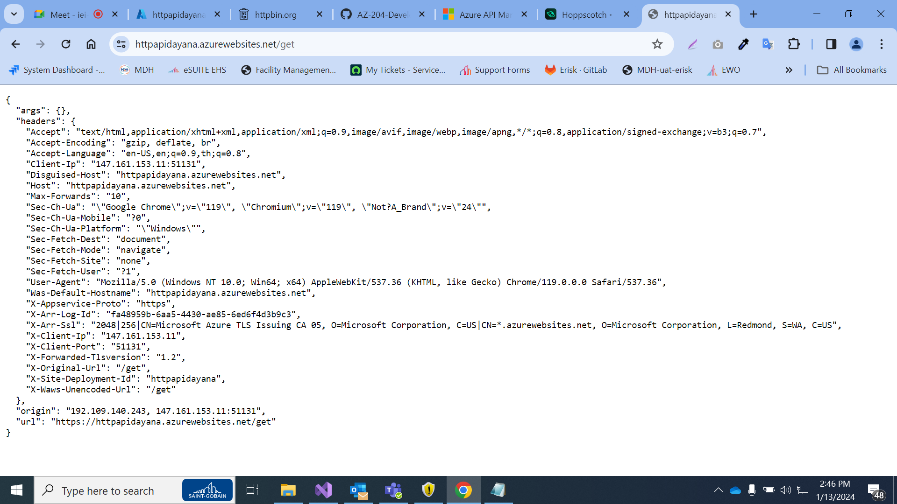

Kubernetes  
